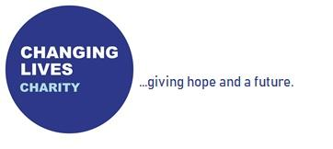
Volunteer Plus Programme –
Enquiry Form
Date of enquiry:

Applicant Name:

Current address:

Telephone number:

Email address:

DOB:

Which of the following have you experienced? (tick all that apply)
Mental health issues
Addiction
Offending
Homelessness
In which of the following area(s) would you like to engage with? (tick all that apply)
Education, training & employment
The Life Course
Mentoring
Counselling
Andrew House (residential)
Do you have a history of any of the following? (tick all that apply)
Arson
MAPPA
RSO
Addiction:
What substance(s) have you used?
Which would you say have been problematic?

How long have you been clean/sober?
Please provide details of any previous or current treatment/ recovery.

Mental Health:
Do you have a Mental health diagnosis?

Have you been detained under the Mental Health Act within the last 3 months?
Are you prescribed any medication? if so what

Do you have any significant mobility issues?
Do you have any physical health issues?

Why do you want to join the Volunteer Plus Programme?

What are your expectations of the Volunteer Plus Programme?

What are your short-term goals?

What are your long-term goals?

Do you have any previous voluntary or employment history?

How did you hear about the Volunteer Plus Programme?

Please hand your enquiry form in to the Changing Lives Charity Warehouse ‘Hub’, Unit 2A, Kimberley Road, Clevedon, BS21 6QJ, or send it via email to the Volunteer Plus Manager, Hasina Downie: hasina.downie@changinglives.org.uk.

Next steps (for office use only):
Arrange meeting with HD
Fill out referral form
Area(s) of V+ programme interested in

